AI CONTRACT.
DCIT 208 SOFTWARE ENGINEERING PROJECT.
We, the members of this project team, acknowledge and agree to the following conditions regarding the use of Artificial Intelligence (AI) tools during the development of this project:
- AI Assistance and Understanding.
We acknowledge that AI tools may assist with brainstorming, research, documentation, coding support, and problem-solving. However, AI tools shall not replace individual understanding, learning, or responsibility for the work produced.
- Recording AI Usage.
We agree to accurately document significant AI usage in the project's
AI USAGE.md file and any other documentation required by the course.
- Protection of Confidential Information.
We agree not to paste or upload confidential client information, passwords, credentials, private records, sensitive personal data, or any other information that is restricted into public AI tools.
- Individual Accountability.
We understand that every team member is responsible for understanding and being able to explain their contributions to the project. Any member who is unable to explain their submitted work may receive zero individual credit for that work.
- Team Acknowledgement.
By signing below, each team member confirms that they have read, understood, and agreed to comply with this AI contract.

Name | Student ID | 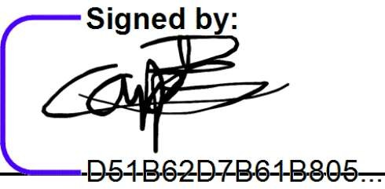  Signature | Date
Terrence Aseda Ogo | 22330566 | 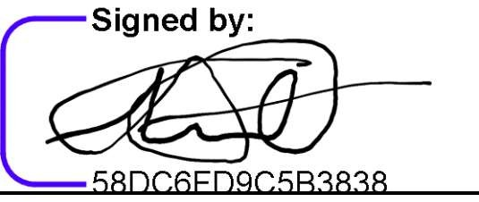 | June 19, 2026
Jeremy Malm | 22310005 | 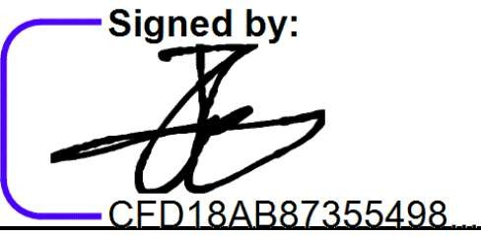 | June 19, 2026
Kimathi Christian | 22308781 |  | June 19, 2026
Osafo
Bi1a1 El Masri El  Chaarani | 22369794 | 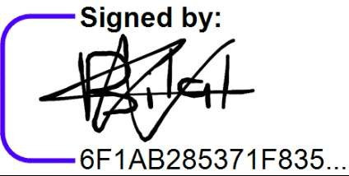 | June 19, 2026
Prince Mashood Mahama Sugri | 22359192 |  | 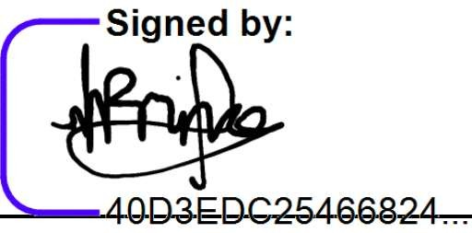  June 19, 2026
Nathan Jojo Timothy Mensah | 22385716 |  | 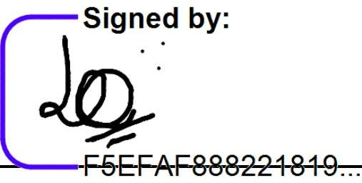  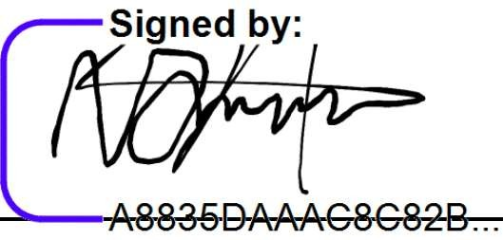  June 19, 2026
Lord Dziedzom | 22374358 |  | June 19, 2026
Yao Fianu

